Adverse
Brand Guidelines
1.0 / 2024

Table of Contents
1. Adverse Brand Guidelines
2. Table of Contents
3. Our Story
4. Our Position
5. Our Audience
6. Our Voice
7. Our Logo
8. Our Colors
9. Our Typography
10. Our Imagery
11. Our Graphic Elements
12. Brand in Action
13. Contact

Adverse Brand Guidelines
Your dysfunctional office, animated.
This document is the official guide to the Adverse brand. It contains everything you need to understand our story, our strategy, and our visual and verbal identity. Consistent application of these guidelines is essential to building a strong, recognizable, and resonant brand. Welcome to the agency.

Table of Contents
- Our Story
- Our Position
- Our Audience
- Our Voice
- Our Logo
- Our Colors
- Our Typography
- Our Imagery
- Our Graphic Elements
- Brand in Action
- Contact

Our Story
This is the story of Adverse. It outlines our core purpose, our ultimate ambition, and the values that guide every decision we make, from script to screen.

The Origin of Cynical Surrealism
The idea for Adverse was born out of a specific kind of exhaustion. We looked at prestige dramas like Mad Men, which masterfully explored the internal, existential dread of professional life, and wonderfully chaotic cartoons like Regular Show, which celebrated unhinged absurdity. But where was the show that lived in the space between? Adverse was created to fill that gap. It’s our attempt to animate anxiety, to satirize the corporate rituals we all endure, and to build a world where the most honest character moments happen amidst the most surreal circumstances. It’s a show for anyone who has ever looked around their office and thought, 'This can't be real.' We’re here to say: you’re right, it’s not. And it’s funnier that way.

Our Mission
To satirize the absurdities of the advertising world for a generation that navigates corporate life with a mix of existential dread and dark humor.

Our Vision
To become the cultural touchstone for workplace satire in adult animation, celebrated for its unique blend of sharp drama, surreal comedy, and visual innovation.

Our Values
- Cynical Wit, Existential Heart: We balance rapid-fire, intelligent satire with moments of genuine pathos. The humor is sharp, but it serves to reveal deeper truths.
- Visual Dissonance as Metaphor: Our visual style is a deliberate clash between grounded, mid-century modern aesthetics and chaotic, surreal animation, representing our characters' internal chaos.
- Intellectual Honesty: We trust our audience. We don't over-explain jokes, simplify complex themes, or shy away from the darker aspects of our world.
- Unapologetic Satire: We take aim at the sacred cows of corporate culture, advertising, and the myth of the tortured creative genius. Our critique is pointed and unafraid to be uncomfortable.

Our Position
This section defines our unique place in the market, who we are for, and what makes us different from any other show.

Unique Value Proposition
The prestige drama and period aesthetic of Mad Men, animated with the surreal, chaotic comedy of Regular Show.

Positioning Statement
For cynical creatives and disillusioned professionals who grew up on surreal cartoons, Adverse is the adult animated series that delivers a cathartic satire of workplace absurdity because it blends sharp, character-driven drama with visually inventive chaos. Unlike BoJack Horseman, which internalizes its existential dread, Adverse externalizes it, turning the psychological pressures of corporate life into literal, animated monsters.

Brand Pillars
- Workplace Satire Amplified: We go beyond generic office humor to dissect the specific language, rituals, and ethical compromises of the advertising industry.
- Prestige Character Drama: We focus on complex, flawed characters navigating ambition, addiction, and identity crisis, inspired by the depth of prestige television.
- Surreal Visual Storytelling: We leverage animation to its fullest potential, where visual gags and surreal sequences are integral to the plot and character development.

Our Audience
We create for a specific viewer in mind. This section details the archetypes of our core audience, ensuring we always speak their language and connect with their worldview.

Primary: Leo, The Nostalgic Creative
Aged 29-35, Leo is a creative professional who grew up on Cartoon Network and now binge-watches critically acclaimed dramas. He values creative authenticity and intellectual stimulation but feels stifled by corporate clients and struggles with burnout. He's drawn to our blend of mid-century design and surreal animation, and responds to messaging that acknowledges his intelligence and cynicism.

Primary: Alex, The Animation Connoisseur
Aged 22-28, Alex is an animation student or freelance artist who judges a show by its keyframes. They value artistic innovation, bold storytelling, and respect for the medium. They are frustrated by generic art styles and premature show cancellations. Alex is specifically drawn to our unique visual challenge of blending aesthetics and will act as a key evangelist within fan communities.

Secondary: Maya, The Disillusioned Professional
Aged 30-40, Maya is a manager in a corporate field like tech or marketing. She feels like a cog in the machine, tired of corporate jargon and formulaic TV. She values sharp, intelligent humor and emotional honesty. She will discover Adverse through word-of-mouth and critical acclaim, finding catharsis in seeing her professional frustrations satirized on screen.

Our Voice
Our voice is how our brand's personality is expressed. It's not just what we say, but how we say it, ensuring we sound consistently like ourselves at every touchpoint.

Our Archetype: The Jester Sage
Adverse blends the sharp, absurd humor and irreverence of the Jester with the intellectual depth and social commentary of the Sage. We use humor to reveal uncomfortable truths. It's the smart-aleck who's also the smartest person in the room, delivering uncomfortable truths with a smirk.

Personality Traits
- Cynically Witty: Delivers sharp, intelligent humor with a jaded, knowing edge.
- Surrealistically Playful: Finds humor in the absurd and uses fantastical elements to exaggerate reality.
- Intellectually Honest: Doesn't shy away from uncomfortable truths or complex themes.
- Existentially Empathetic: Recognizes the universal struggles of modern life and work beneath the satire.
- Irreverently Observational: Points out the absurdities of corporate culture with a keen, often sarcastic, eye.

Lexicon
Words We Use: absurd, surreal, chaos, existential, dread, satire, wit, disillusioned, cathartic, unhinged.
Words We Never Use: wholesome, inspirational, heartwarming, family-friendly.

Voice Do's
- Maintain a cynical, witty edge. Even moments of pathos should be understated.
- Let the satire speak for itself, trusting the audience to get the critique.
- Ensure surreal elements are metaphorically rooted in character or theme.
- Subvert and satirize corporate language ironically.
- Embrace intellectual honesty and complex ideas.

Voice Don'ts
- Don't be overly earnest or saccharine.
- Don't be preachy or overtly moralistic.
- Don't be purely absurd without grounding.
- Don't sound like generic corporate speak.
- Don't be simplistic or talk down to the audience.

Our Logo
Our logo is the most recognizable element of our brand. It visually represents our core concept: a sophisticated, orderly world being fractured by surreal chaos. Consistent and correct application is crucial for maintaining brand integrity.

The Logo Suite
Our logo system is designed to be flexible across all applications. The primary logo, 'The Glitch in the Grey Flannel,' is our main identifier. It is supported by horizontal and stacked variants, a standalone brand mark for small applications, and a clean wordmark for text-heavy contexts. Single-color versions are available for situations requiring high contrast or specific print methods.

Clear Space
To ensure legibility and impact, always maintain a clear space around the logo. This exclusion zone should be equal to at least the x-height of the letter 'A' in the 'Adverse' wordmark on all sides. No other text or graphic elements should intrude into this space.

Minimum Size
The logo must always be legible. For digital applications, the primary logo should never be smaller than 120 pixels wide. For print, it should be no smaller than 1.5 inches wide. The standalone brand mark (the glitched 'A') can be used at sizes as small as 16x16 pixels for favicons.

Prohibited Modifications
- Do not stretch, condense, or distort the logo proportions.
- Do not change the approved logo colors.
- Do not rearrange the elements of the logo.
- Do not add unauthorized effects like shadows, glows, or outlines.
- Do not place the logo on a busy or low-contrast background that impairs legibility.

Our Colors
Our color palette is a strategic blend of sophisticated, mid-century tones and chaotic, hyper-saturated accents. This visual dissonance is core to our identity, representing the calm corporate facade and the madness that lies beneath.

Primary Palette
- The foundational colors of our brand, evoking a grounded, vintage, and intellectual mood.
#556B2F | Olive Grove | HEX: #556B2F | RGB: 85, 107, 47 | CMYK: 65, 45, 100, 30 | Pantone: PMS 5747 C

#EAAA00 | Mustard Gold | HEX: #EAAA00 | RGB: 234, 170, 0 | CMYK: 9, 36, 100, 1 | Pantone: PMS 124 C

Accent Color
The color of chaos. This hyper-saturated hue is used to signify a break from reality, a glitch in the system, or a moment of surreal mayhem. Use it sparingly for maximum impact.
#E5007A | Electric Magenta | HEX: #E5007A | RGB: 229, 0, 122 | CMYK: 0, 100, 3, 0 | Pantone: PMS Process Magenta C

Neutral Palette
Our neutrals provide a warm, clean canvas, supporting the primary and accent colors. They evoke the textures of a mid-century office: paper, wood, and shadow.
- Charcoal
- Office Beige
- Teak
#36454F | Charcoal | HEX: #36454F

#F5F5DC | Office Beige | HEX: #F5F5DC

#B07953 | Teak | HEX: #B07953

Color Usage
▶ Our palette follows a 60-30-10 principle. The grounded, mid-century colors (Olive, Teak, Beige) should form the base (60%). Secondary colors (Mustard Gold) provide creative energy (30%). Accent colors (Electric Magenta) are used sparingly for surreal moments and calls-to-action (10%).

Our Typography
Typography is our voice made visible. Our font system balances the sophistication of prestige drama with the clarity of modern design, reflecting our unique tonal blend.

Heading Typeface
An elegant, high-contrast serif that evokes the sophisticated editorial design of 1960s magazines. It provides the 'prestige drama' feel and grounds the identity in a classic, intelligent style.
Playfair Display
Weights: Bold (700), Black (900)
Usage: Headlines, titles, and major callouts.

Body Typeface
A highly legible, warm humanist sans-serif that offers excellent readability. Its clean structure provides a clear, no-nonsense counterpoint to the decorative heading font, ensuring our witty dialogue is easy to consume.
Source Sans Pro
Weights: Regular (400), SemiBold (600)
Usage: Body copy, paragraphs, UI text, and captions.

Accent Typeface
A monospaced font used for UI elements, on-screen 'glitch' text, or internal monologues, adding a technical, slightly detached feel that enhances surreal or psychological moments.
JetBrains Mono
Weights: Regular (400)
Usage: Code snippets, UI labels, internal monologue text.

Typographic Scale & Hierarchy
A clear hierarchy ensures our messaging is easy to navigate. Headings should always be Playfair Display, while body text is Source Sans Pro. Use a consistent type scale (H1: 64px, H2: 48px, H3: 36px, Body: 16px) with a line height of 1.2 for headings and 1.5 for body copy to maintain rhythm and readability.

Our Imagery
Our visual approach to imagery and animation captures the mood of 'Cynical Surrealism'—a world that is simultaneously sophisticated, unsettling, and darkly humorous.

Animation & Art Style
Our core style is 'Mid-Century Modern Mayhem.' It is inspired by the UPA school of animation, featuring minimalist backgrounds, clean lines, and graphic shapes. This grounded, sophisticated reality is intentionally shattered by chaotic, surreal elements drawn in a looser, more absurdist style. This visual dissonance is not a gimmick; it is the core metaphor for our characters' fractured mental states.

Photography Style
When using photography for promotional materials, the style should reflect our animation's mood. Lighting should be dramatic and low-key, with deep shadows. Color treatment should favor muted, vintage tones, with hyper-saturated accent colors used only for surreal intrusions. Compositions should be clean and architectural, creating a sense of sophisticated weariness and underlying absurdity.

Imagery Don'ts
- Do not use bright, generic stock photography.
- Do not use imagery that is overtly cheerful or saccharine.
- Do not use uninspired, flat compositions.
- Do not use literal representations of chaos without artistic intent.
- Do not use imagery that feels cheap or lacks a clear directorial vision.

Our Graphic Elements
Supporting graphic elements provide texture, depth, and personality to our visual identity, reinforcing our core themes of order and chaos across all brand communications.

Brand Pattern
Our primary brand pattern is a seamless composition of mid-century modern geometric shapes in our core brand colors. This orderly pattern is subtly interrupted by 'glitch' or 'warp' effects in our accent colors, mirroring the show's narrative theme.

Textures
A subtle, seamless teak wood grain texture can be used to evoke mid-century furniture and provide a tactile feel to digital and print applications. This grounds our designs in the physical reality of the show's world.

Iconography
Our icon set is duotone. The primary icon shape is rendered in solid Charcoal, representing the corporate world. A secondary 'glitch' element within the icon is rendered in Electric Magenta, symbolizing the surreal intrusion. This carries the core brand concept down to the smallest scale.

Line Work
Our visual system uses two types of lines. Clean, graphic, UPA-style lines in neutral colors are used for structure, grids, and dividers. They represent order. These are contrasted with chaotic, hand-drawn, wobbly, or fragmented lines in accent colors, which are used to break the grid and represent chaos.

Brand in Action
This is how our brand comes to life. The following examples show how our strategy and visual systems work together across different real-world touchpoints.

Website Homepage
The website hero immediately establishes the 'Mad Men meets Regular Show' premise with key art featuring a surreal character interaction, our primary logo, and a clear call to action. The design is clean, using our brand typography and color palette to create an immersive first impression.

Business Card
Our business cards balance mid-century professionalism on the front with our chaotic brand pattern on the back. This duality creates a memorable tactile experience that perfectly encapsulates the brand's essence.

Social Media
Instagram posts use consistent templates for quotes, character spotlights, and announcements. This approach reinforces the brand's witty voice and unique visual style, creating a cohesive and recognizable feed.

Merchandise
Apparel and accessories, like T-shirts and mugs, serve as wearable expressions of the brand. Designs feature our logo, key characters, or witty taglines, allowing fans to connect with the show's cynical wit and unique aesthetic.

Contact
For questions regarding these brand guidelines or for access to official brand assets, please get in touch with the appropriate team.
Brand Management: brand@adverse.tv
Press Inquiries: press@adverse.tv
Brand Strategy & Design by Muskoid AI.

Brand Assets
The following assets are part of the official brand identity.
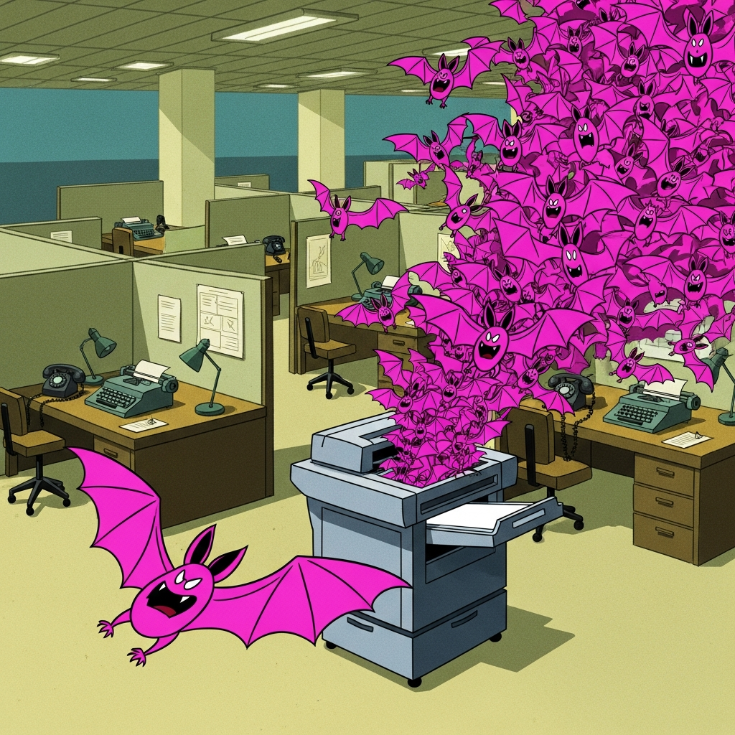
Mood Board

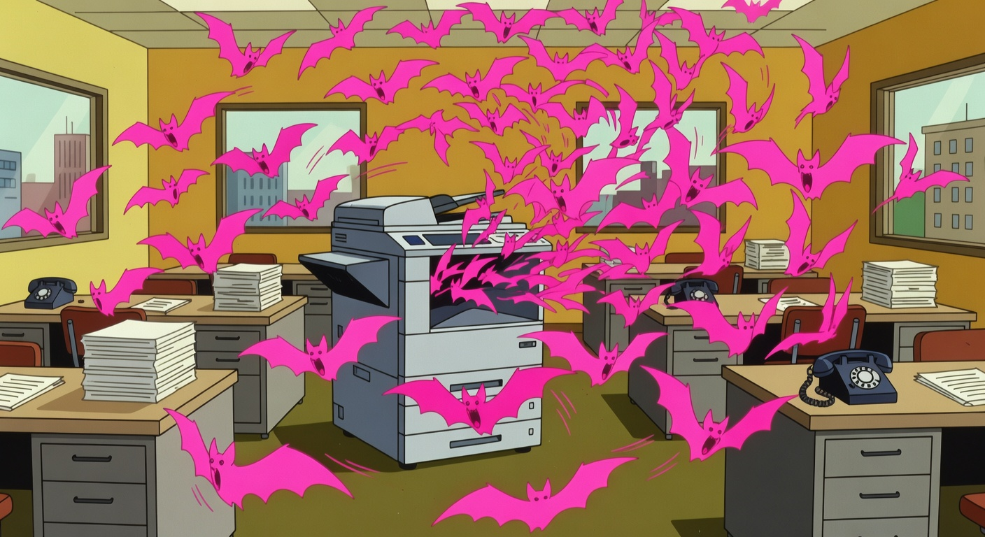
Mood Board

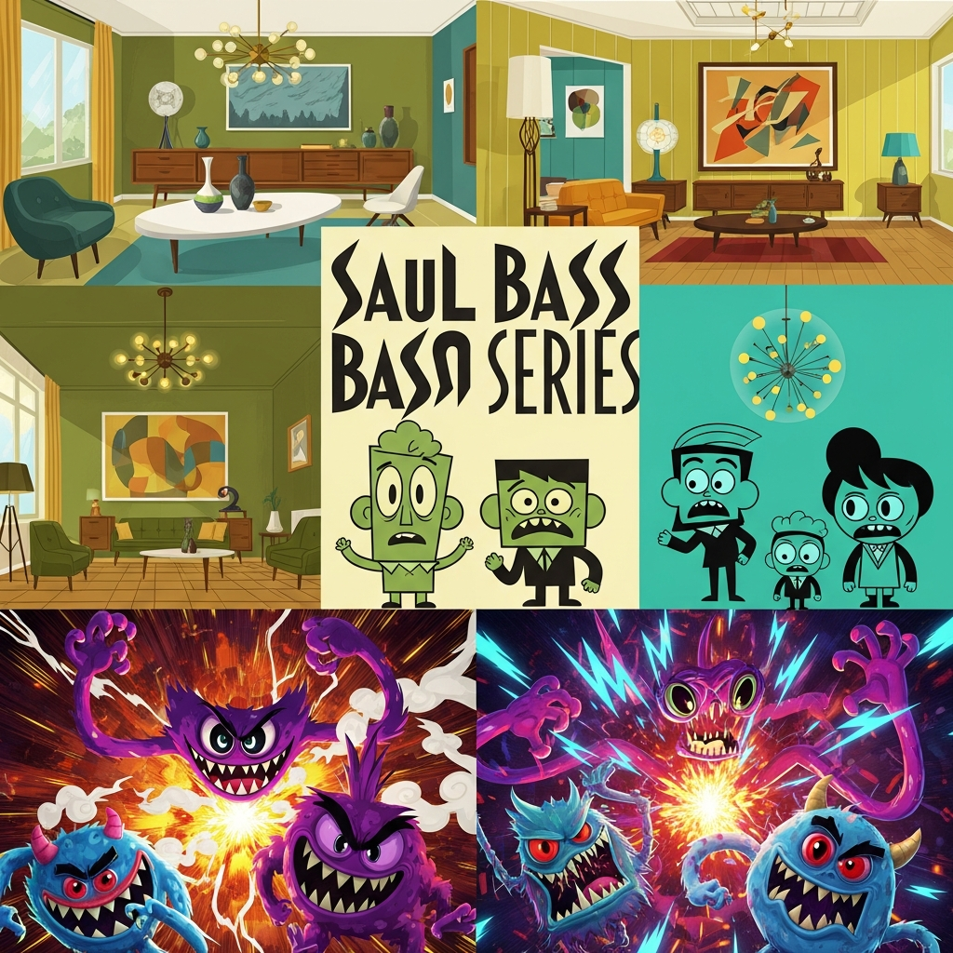
Mood Board

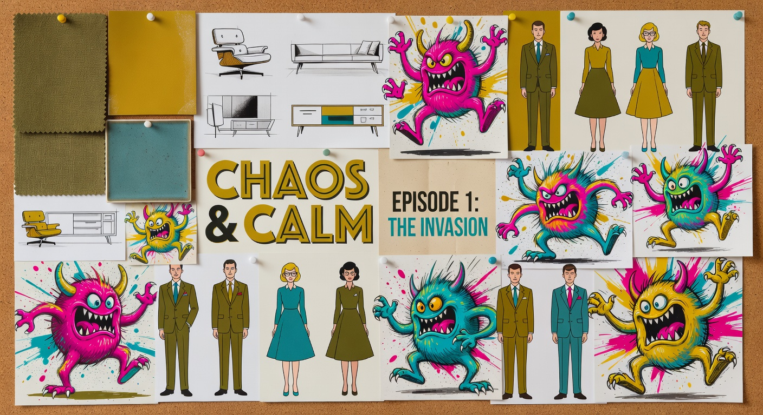
Mood Board

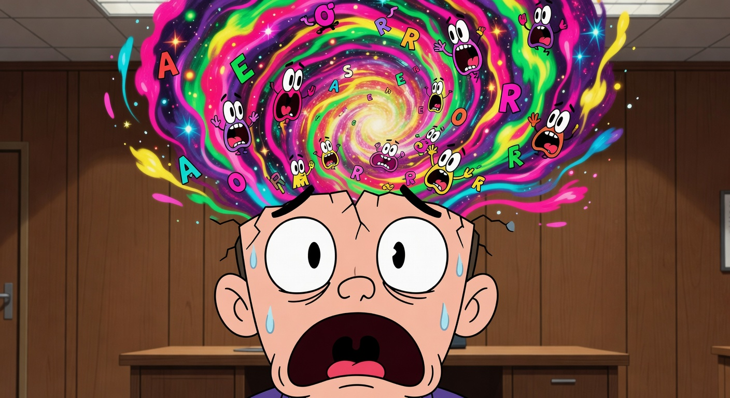
Mood Board

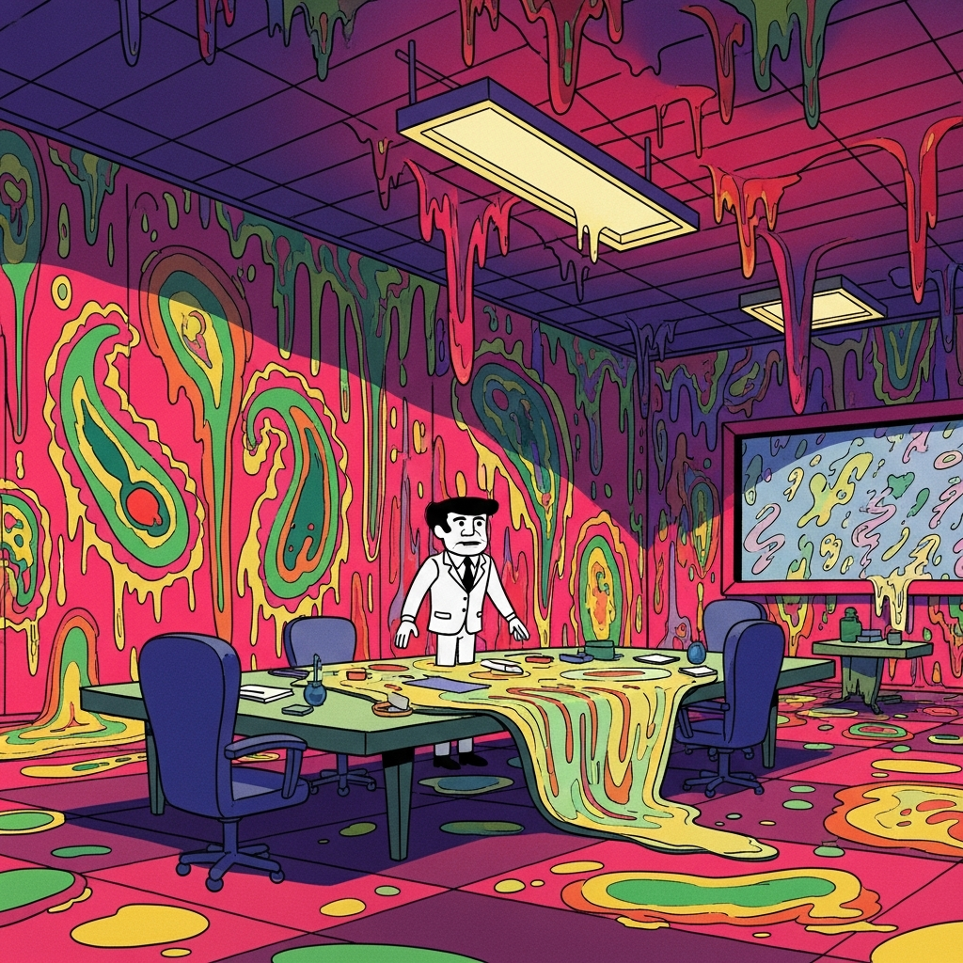
Mood Board

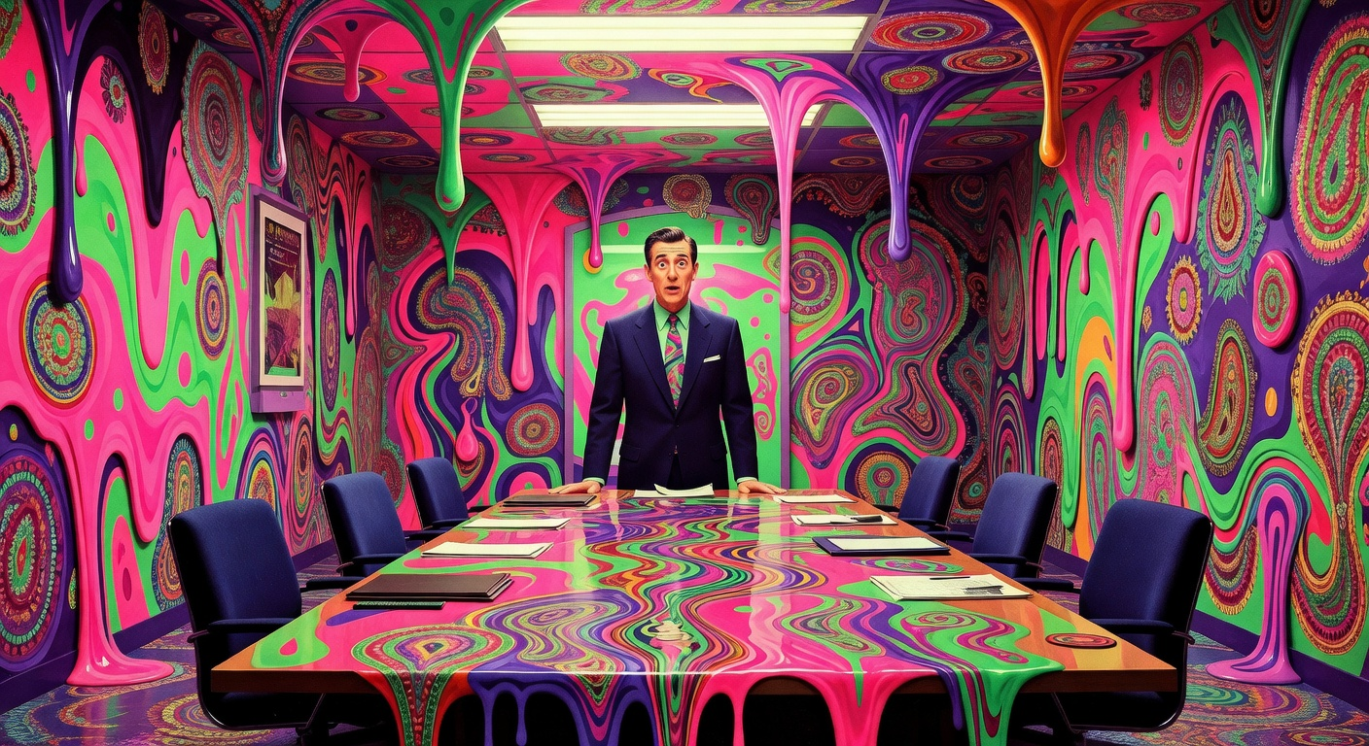
Mood Board

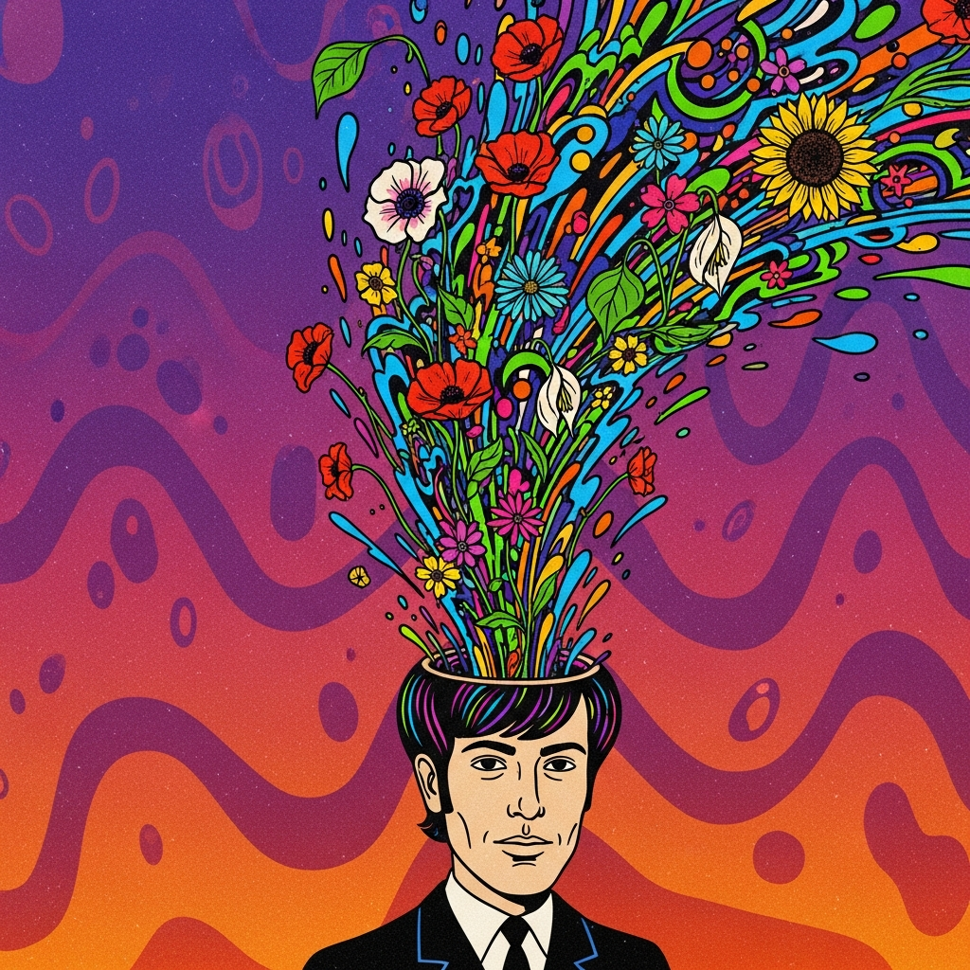
Mood Board

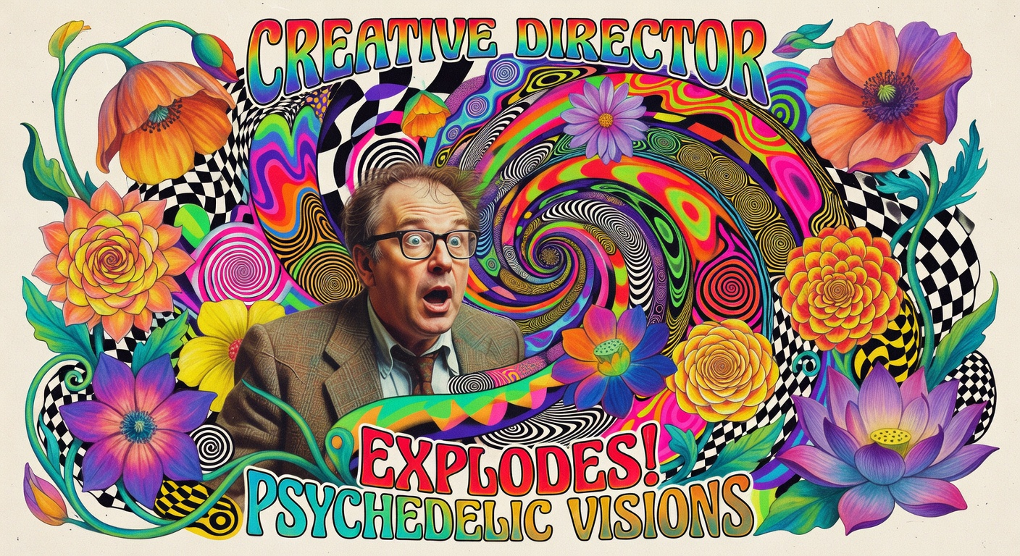
Mood Board

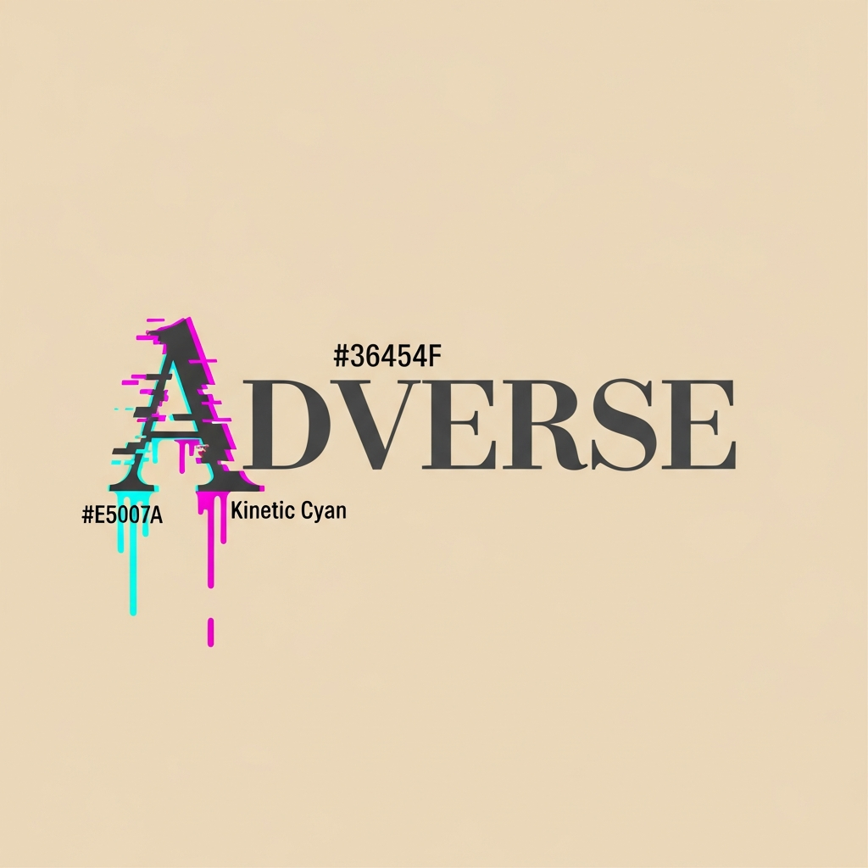
Mood Board

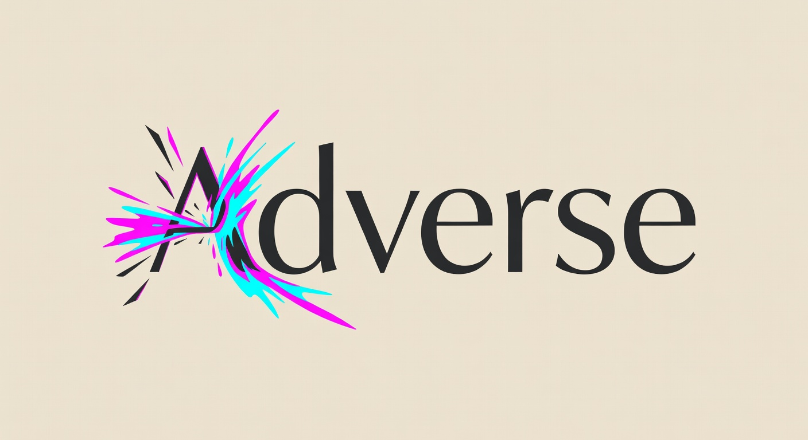
Mood Board

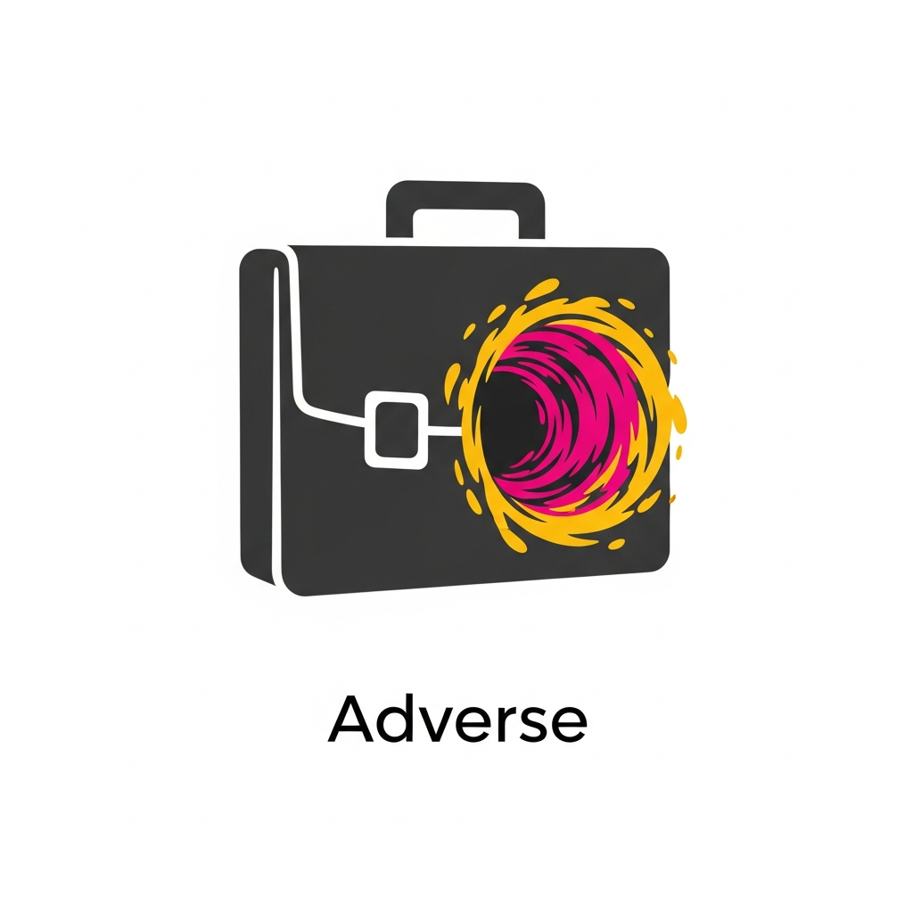
Mood Board

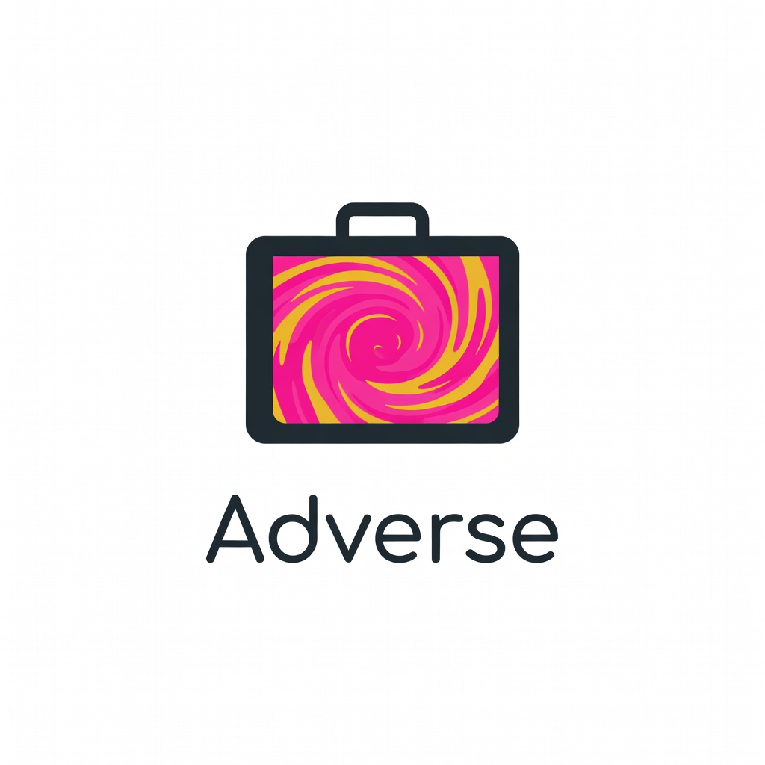
Mood Board

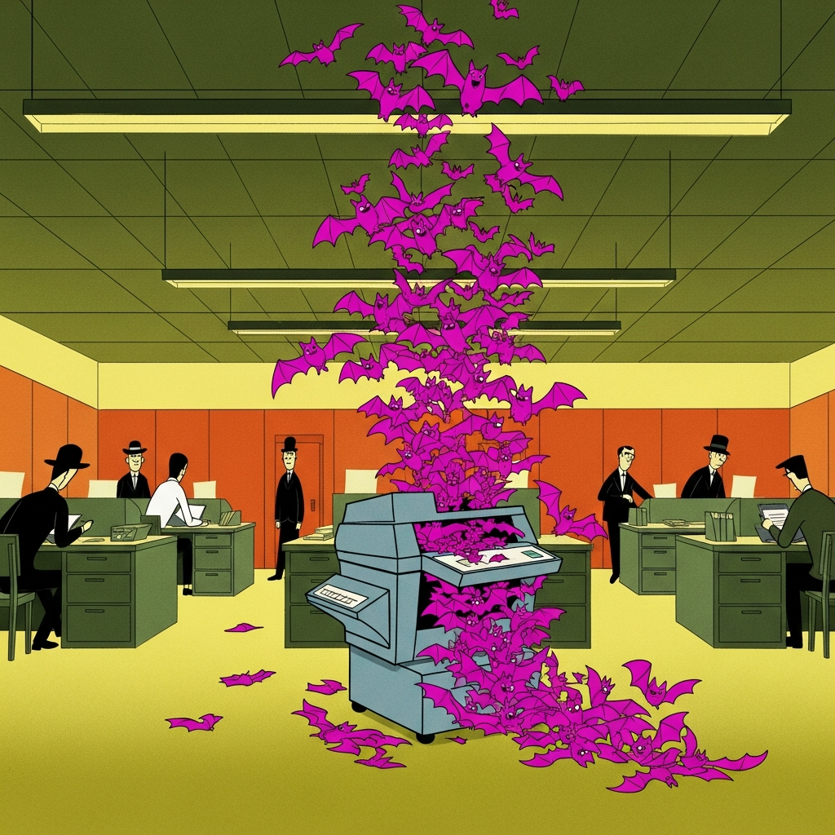
Mood Board

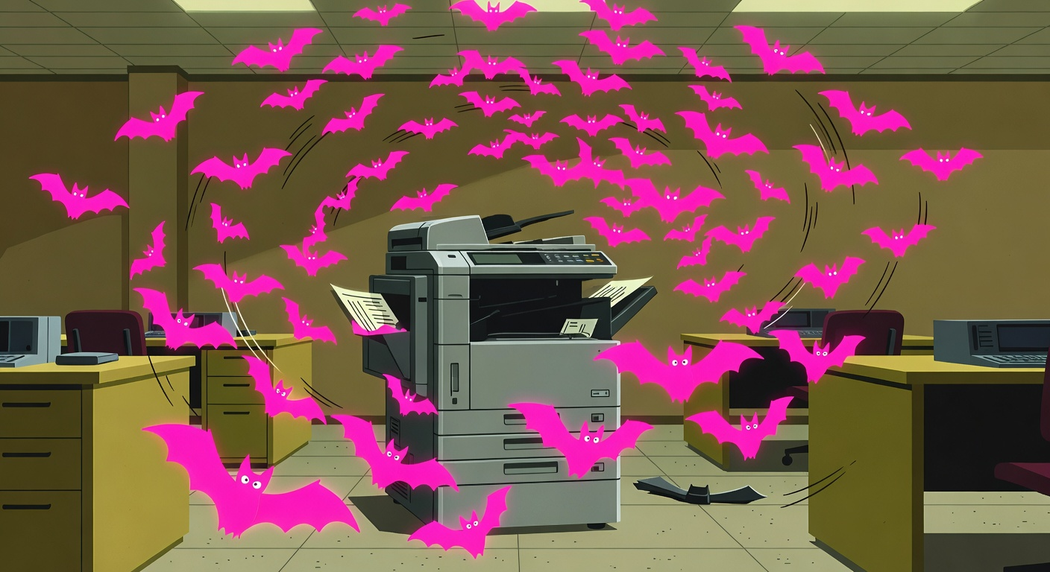
Mood Board

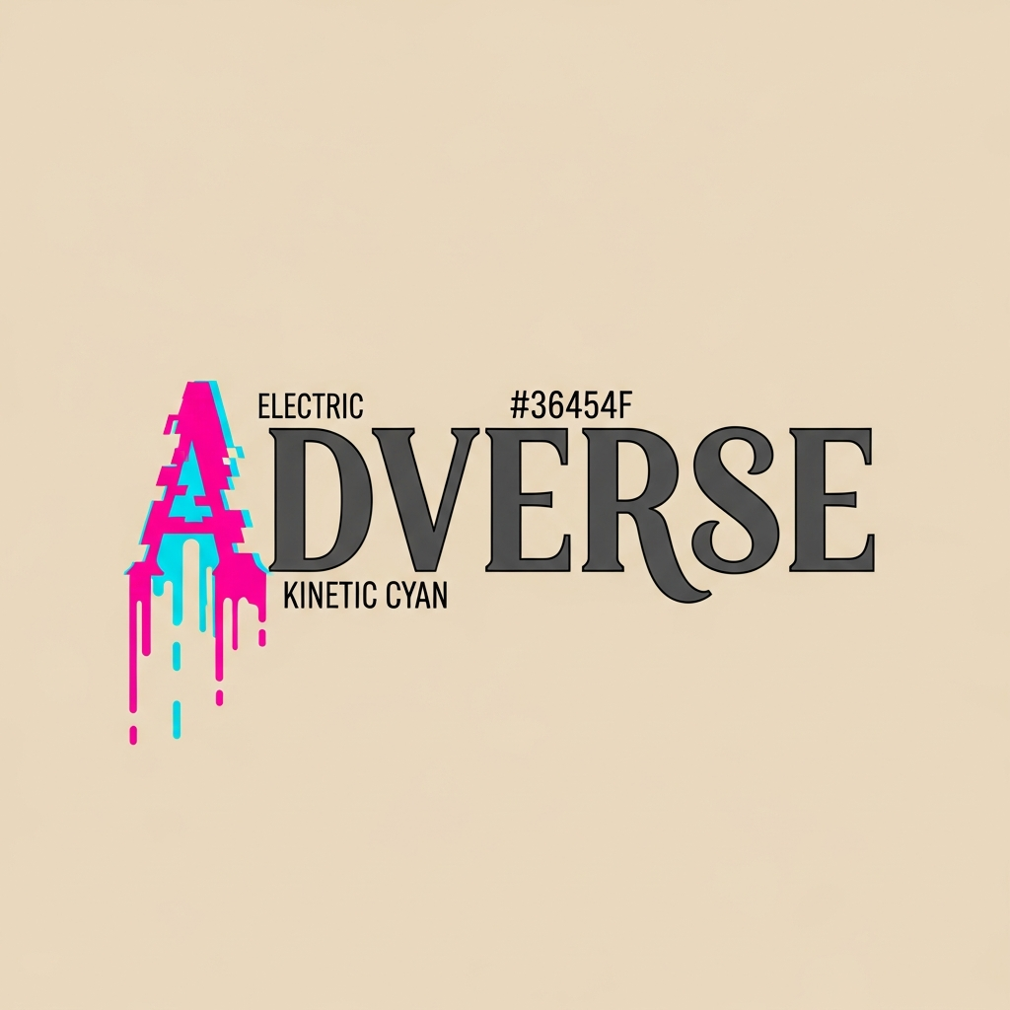
Mood Board

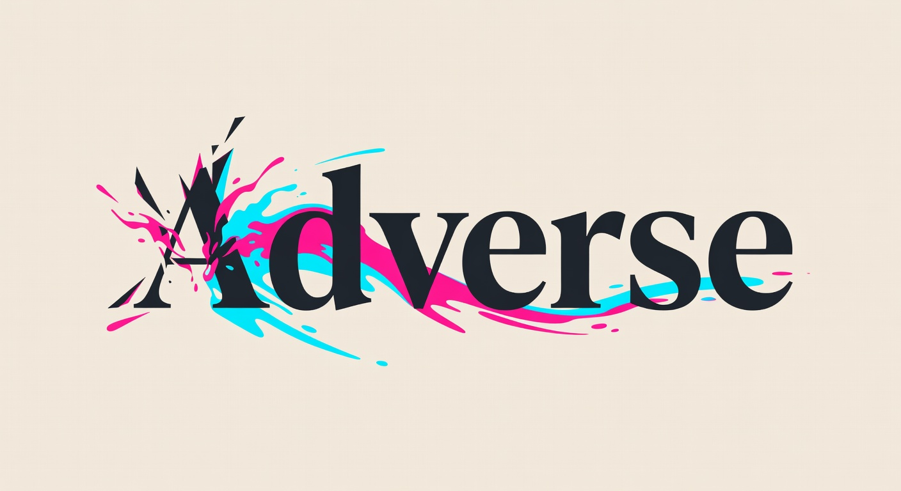
Mood Board

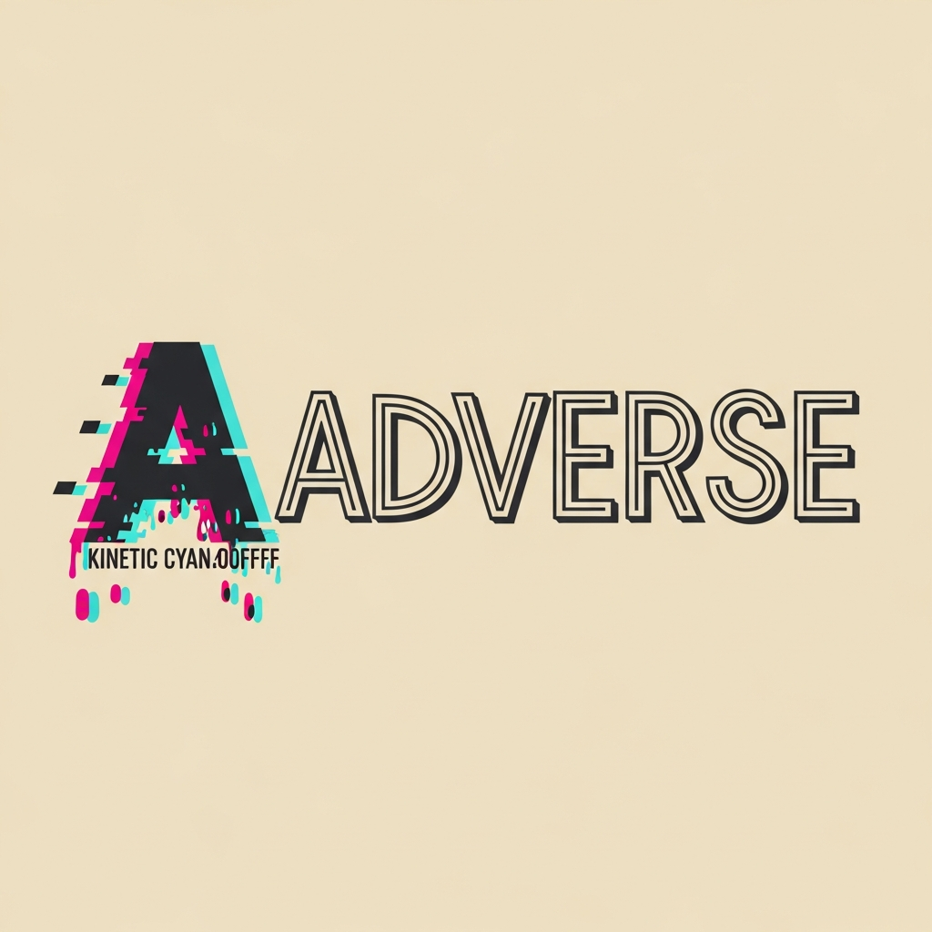
Mood Board

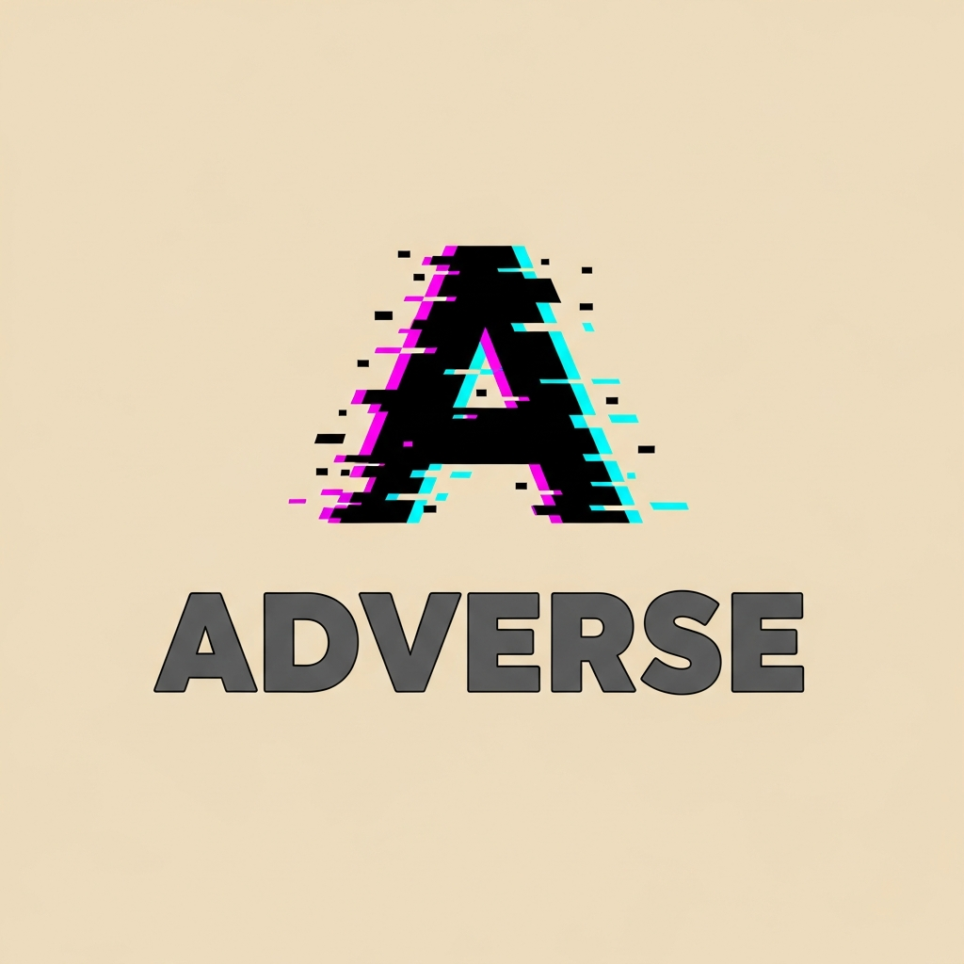
Mood Board

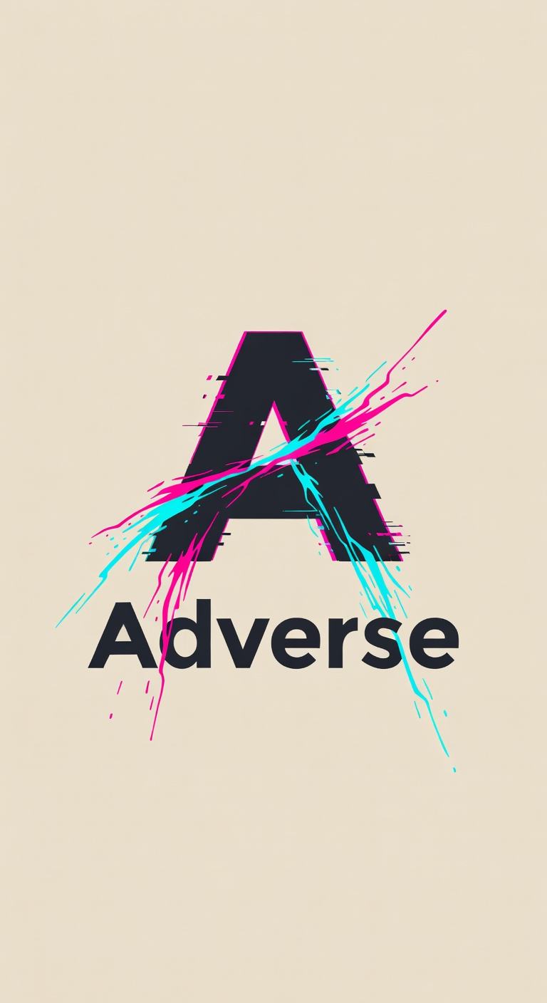
Mood Board

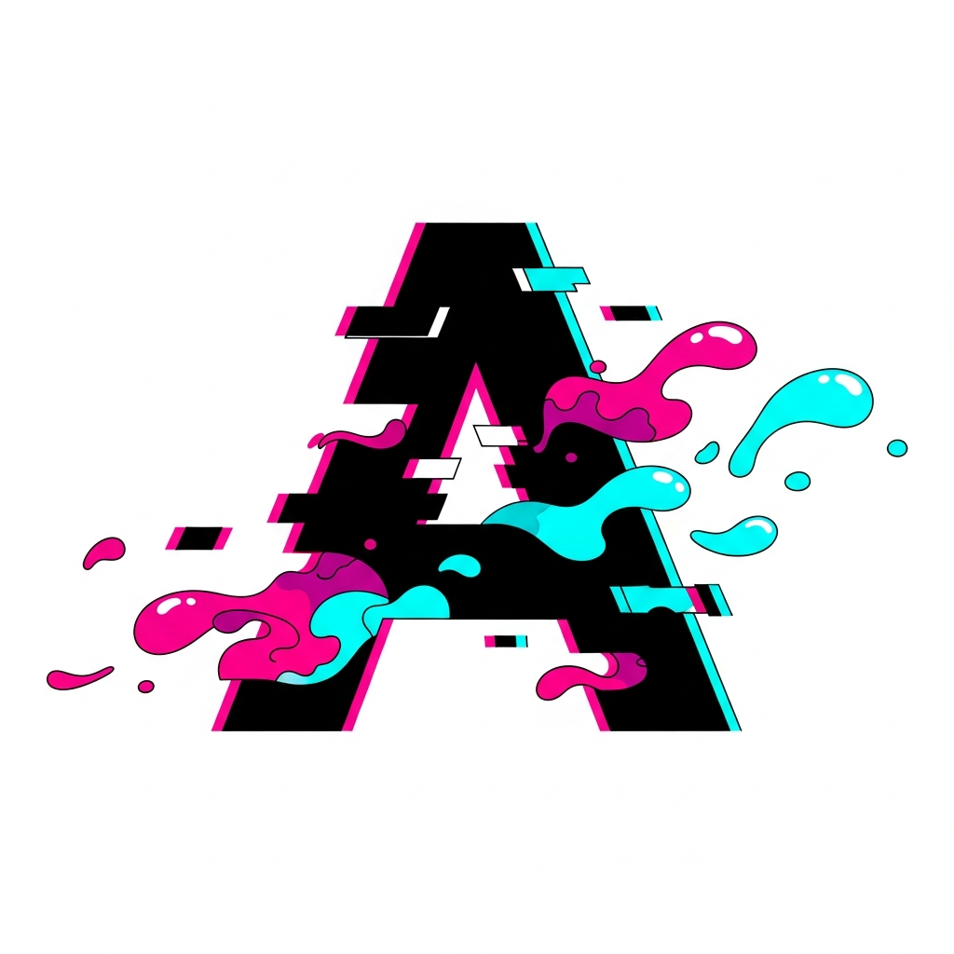
Mood Board

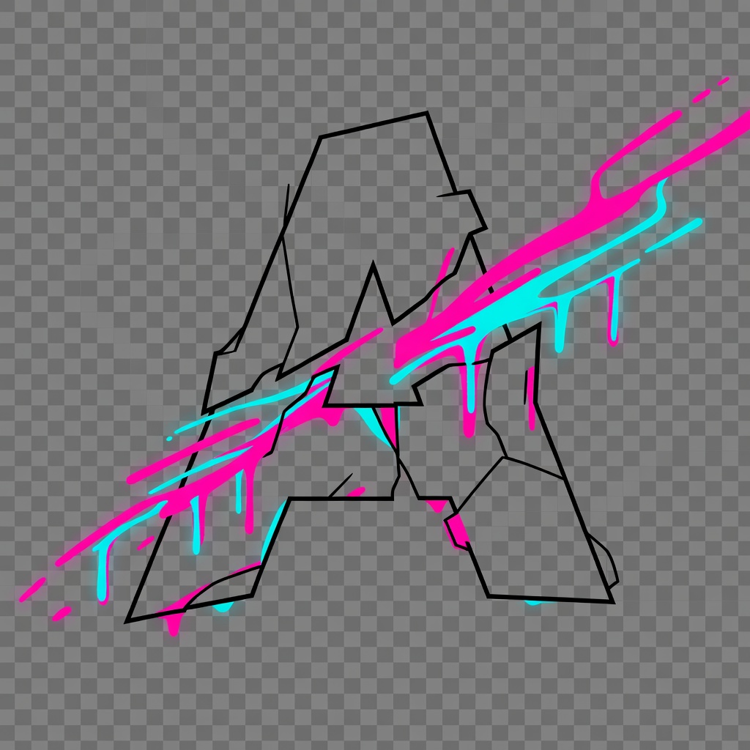
Mood Board

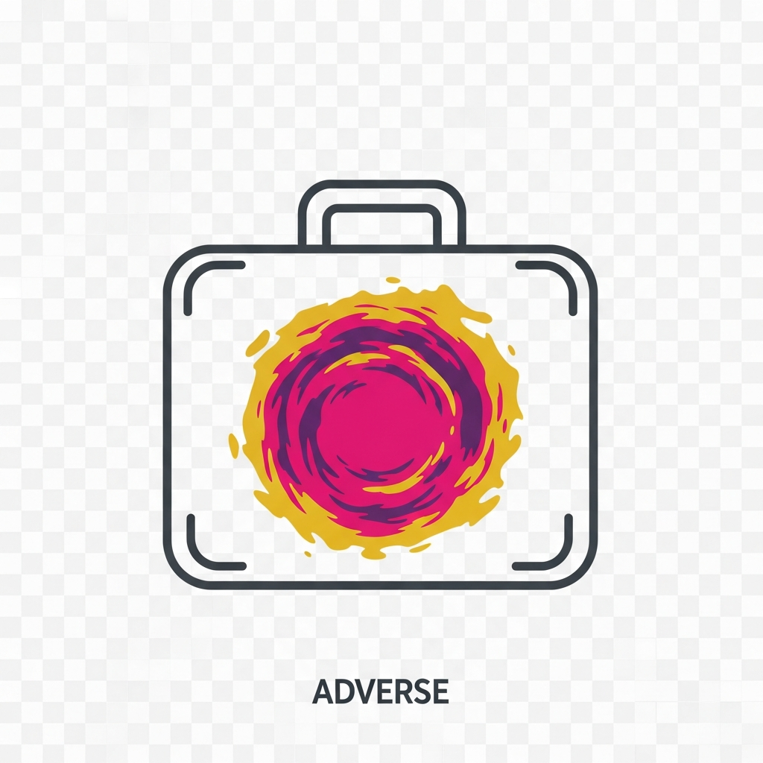
Mood Board

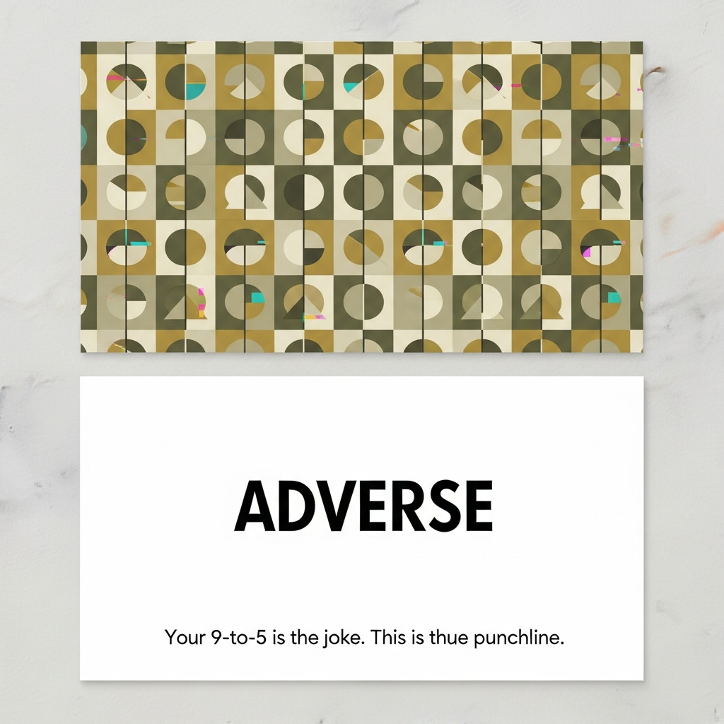
Mood Board

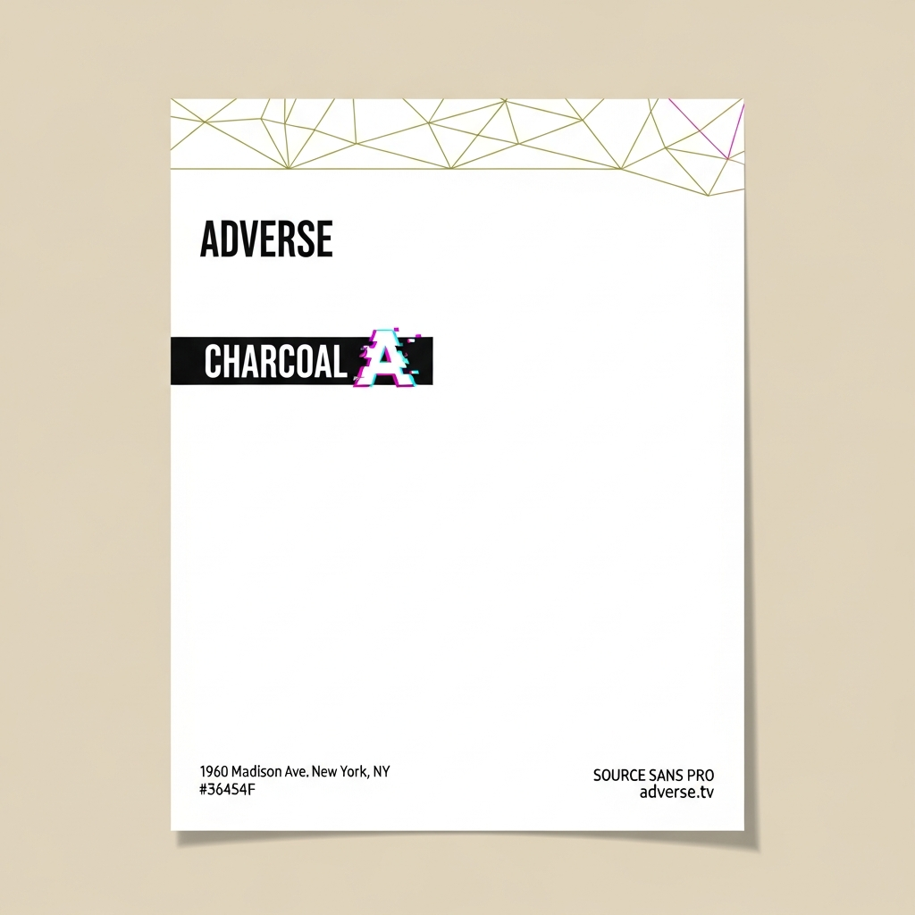
Mood Board

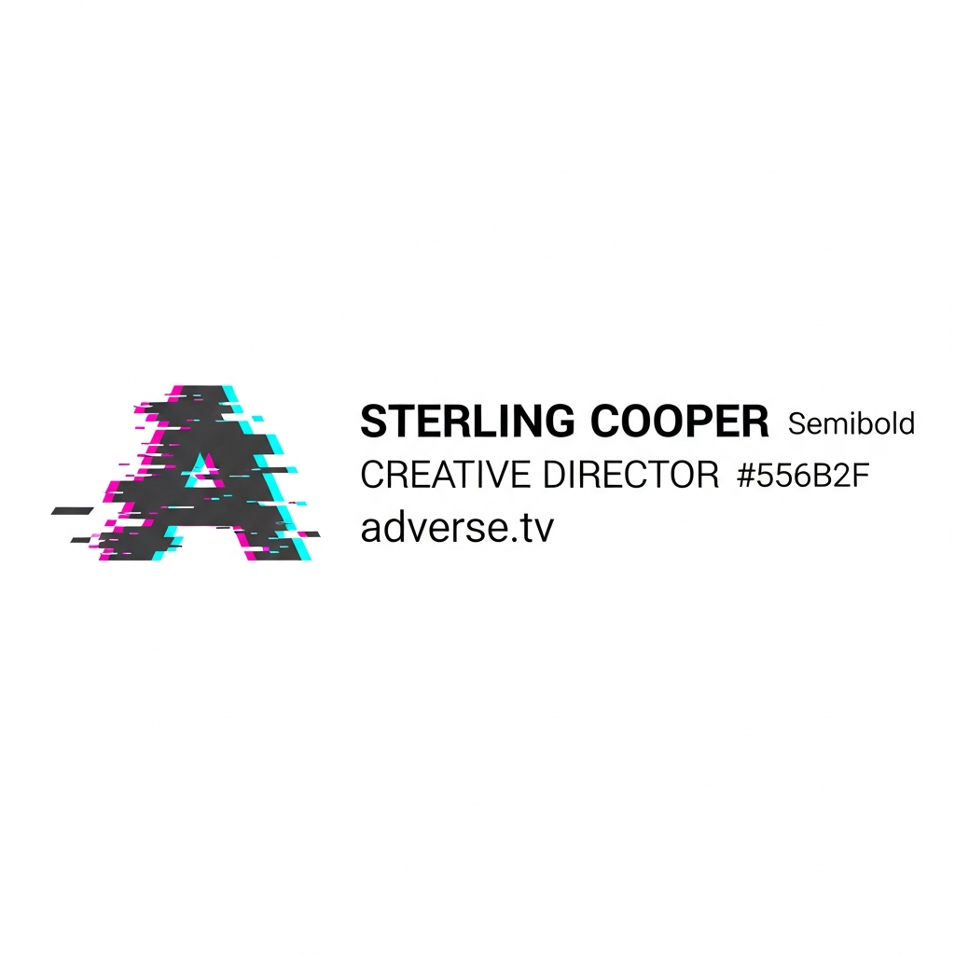
Mood Board

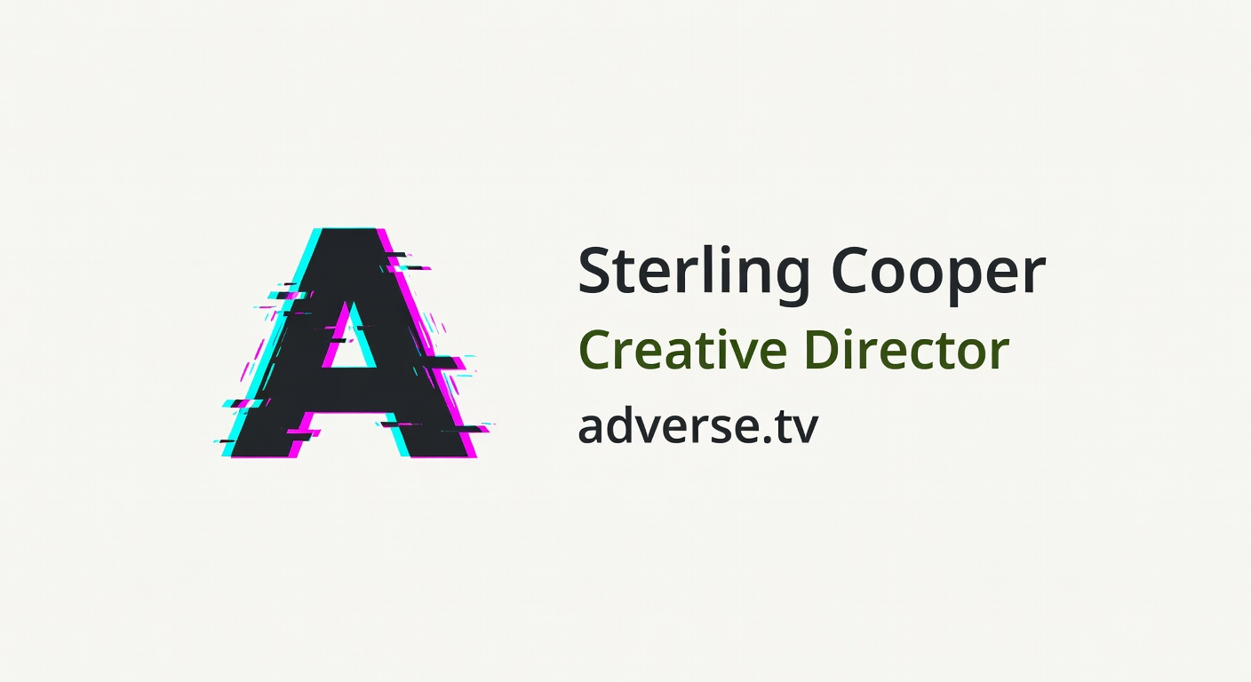
Mood Board

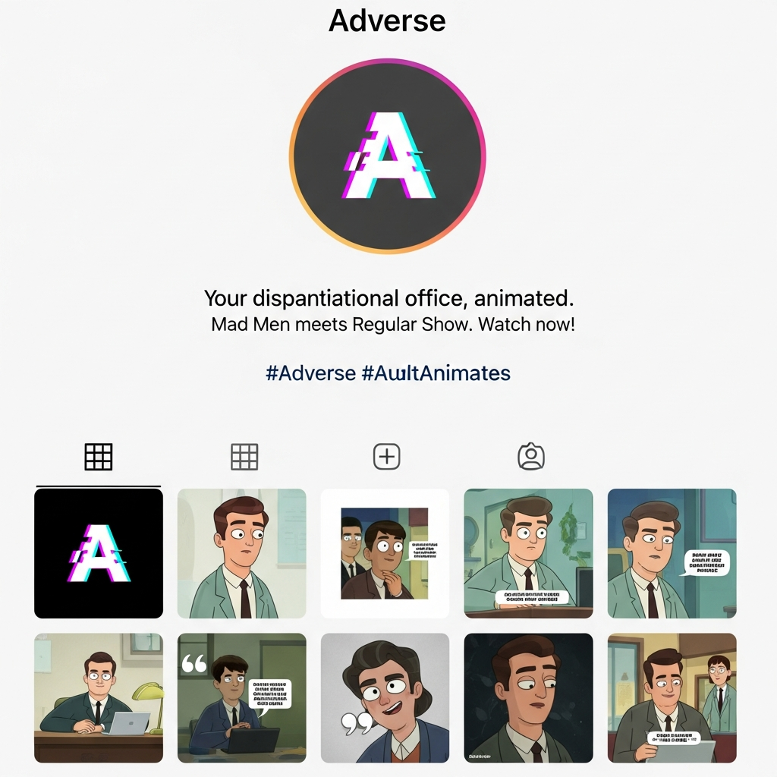
Mood Board

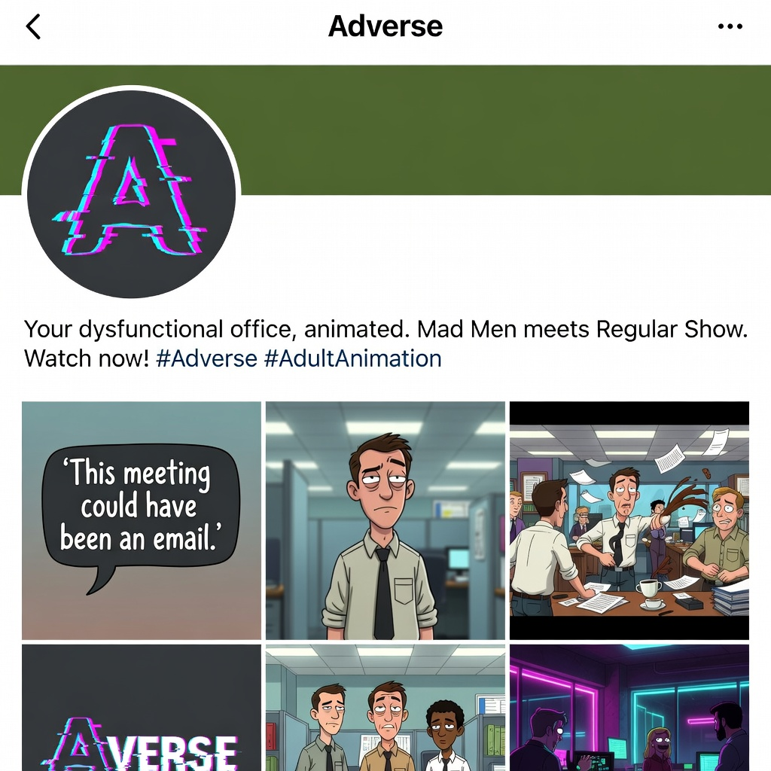
Mood Board

